# Lab 17: Setup Backend REST API

## Objectives

*  Install the backend REST API server
*  Create a custom npm script to run the REST API server
*  Start the REST API server

## Steps

### Install the backend REST API server

1. **Open** a command prompt (Windows) or terminal (Mac).
2. Change the **current directory** to working\keeptrack.
3. **Run** the following commands:

#### Npm

#### npm install json-server@0.16.2

### Create a custom npm script to run the REST API server

1. **Add** a **script** to **start** the **backend** REST API.

#### package.json

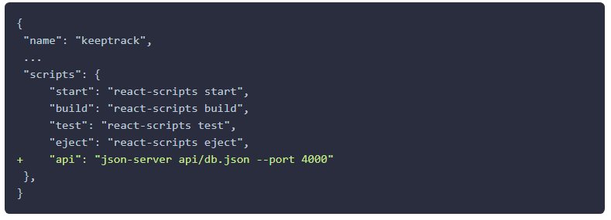

1. Copy the directory labs\js\snippets\lab17\api into the working\keeptrack directory.

### Start the REST API server

1. **In** a command prompt (Windows) or terminal (Mac) with the current **directory** set to working\keeptrack.
2. **Run** one of the following commands:

#### npm

npm run api

The **run** command is short for **run-script**. Running the backend json-server through an npm script ensures that we are using the local version of the server we just installed and not a previously installed global version.

1. The **server** should **start** and **output** similar to the following should display.

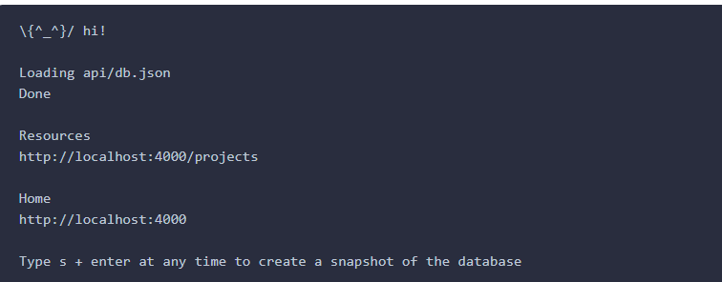

Note that if you visit http://localhost:4000/ you would normally see the json-server landing page but this will not work when you are inside a Create React App project.

1. In your Chrome browser open:

[http://localhost:4000/projects](http://localhost:4000/projects" \t "https://handsonreact.com/docs/labs/js/_blank)

1. You should see JSON data being returned.

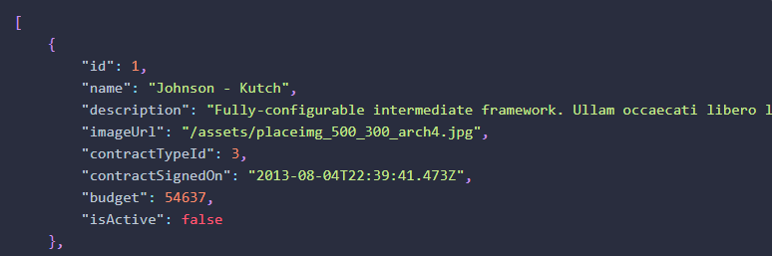

### You have completed Lab 17